5.1 Approximating Areas

In Chapters 1 – 4 we have looked at the application of limits as it related to tangent lines and their slopes. In Chapter 5 turn our attention to a seeming unrelated question of using limits to help determine areas.

General Idea (Part I):
A car is traveling at a constant rate of 50mph for a 2-hour period. Find the total change in position. Represent this quantity as an area on a graph.
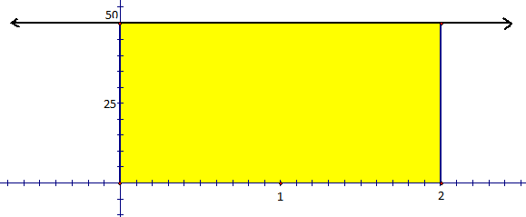
We can clearly see that 50 miles/hour 2 hours = 100 miles.
We can represent this graphically. We will have a horizontal axis representing time and a vertical axis representing miles/hour.
Notice that the area of the shaded rectangle is
Note: When the rate of change of a quantity is positive, the total change in that quantity on some interval can be represented by the area between a function and the horizontal axis on that interval.

General Idea (Part II):
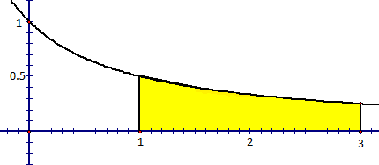
An object travels at ft/sec between the times and seconds. Estimate the total change in position of the object during this time.

Calculating this area will be much more difficult.
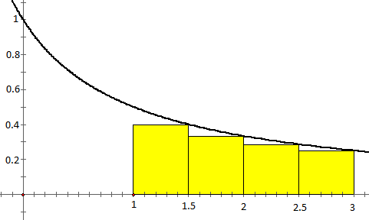
We can break up the interval into smaller subintervals and we can then approximate the total change in position on each subinterval as the area of a rectangle.

The total change in position can be approximated by the sum of the areas of these rectangles.

So we can say that the distance traveled by the object from to is approximately . This is an underestimate of the area (distance travelled).

Exploration: The area A of the region S that lies under the graph of the continuous function f can be approximated by using sum of areas of n approximating rectangles.
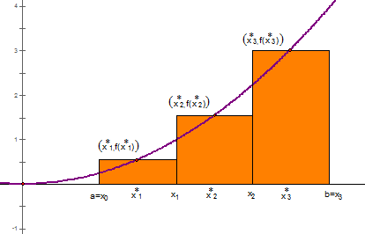
If
- each rectangle has an equal width

- each rectangle has height , where is any number in the ith subinterval

Then the area of each rectangle will be given by the formula .

Therefore the approximation of the area will be given by

Definition: The net area (also called signed area) of a region that lies between the x-axis and the graph of a continuous function may be approximated with a Riemann sum which is a sum of the form
where is a sample point in .

Common Riemann Sums:
- A Left Riemann Sum has the top left corner of each rectangle on the function.
- A Right Riemann Sum has the top right corner of each rectangle on the function.
- A Midpoint Riemann Sum has the midpoint of the top side of each rectangle on the function.

Example 1: Let A be the area of the region that lies above the x-axis and under the graph of between .
- Estimate the area by using a Left Riemann Sum with 4 rectangles.
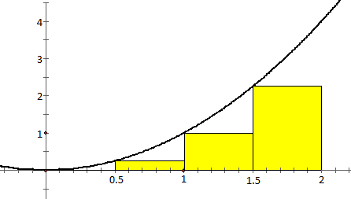
Clearly the width of each rectangle is .
Therefore,

This is an underestimate of the area.
(Note: not all Left Riemann Sums are underestimates)
- Estimate the area by using a Right Riemann Sum with 4 rectangles.
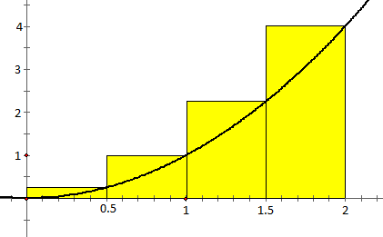

Clearly the width of each rectangle is .
Therefore,

This is an overestimate of the area.
(Note: not all Right Riemann Sums are overestimates)

- Estimate the area by using Midpoint Riemann Sum with 8 rectangles.

Clearly the width of each rectangle is .
Therefore,

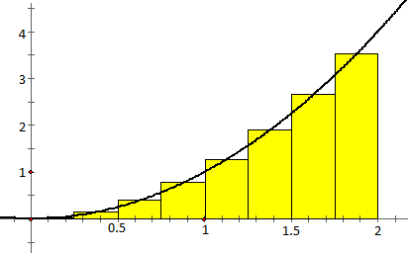

It is difficult to tell if this is an overestimate or underestimate, so we don’t label this as either.

Note: If f takes on both positive and negative values, then the rectangles above the x-axis have positive area and the rectangles below the x-axis have a negative area.

Example 2: Let A be the area of the region that lies between the x-axis and between .

- Estimate the area by using a Riemann sum with left endpoints and 3 rectangles.

Clearly the width of each rectangle is .
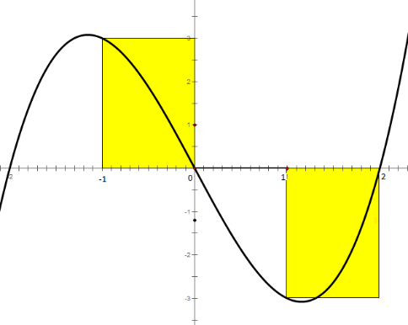
Therefore,

- Estimate the area by using a Riemann sum with right endpoints and 6 rectangles.
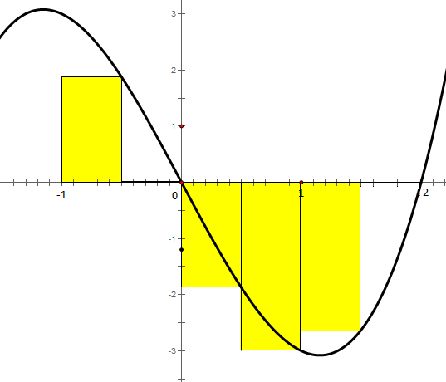
Clearly the width of each rectangle is .
Therefore,

Example 3: Suppose the odometer on our car is broken and we want to estimate the distance driven over a $30$ minute time interval. We take the speedometer readings every 5 minutes and record them in the following table:
Time (hours) | 0 | 1/12 | 2/12 | 3/12 | 4/12 | 5/12 | 6/12
Velocity(mi/h) | 17 | 21 | 24 | 29 | 32 | 31 | 28

- Estimate the distance traveled using left endpoints.

- Estimate the distance traveled using right endpoints.

